/* Ashok

Auditing and Error Handling Lab

6.27.19*/

1. Create dictionary tables in Prospects database for Title, Department, Company and Location –

(Project document)

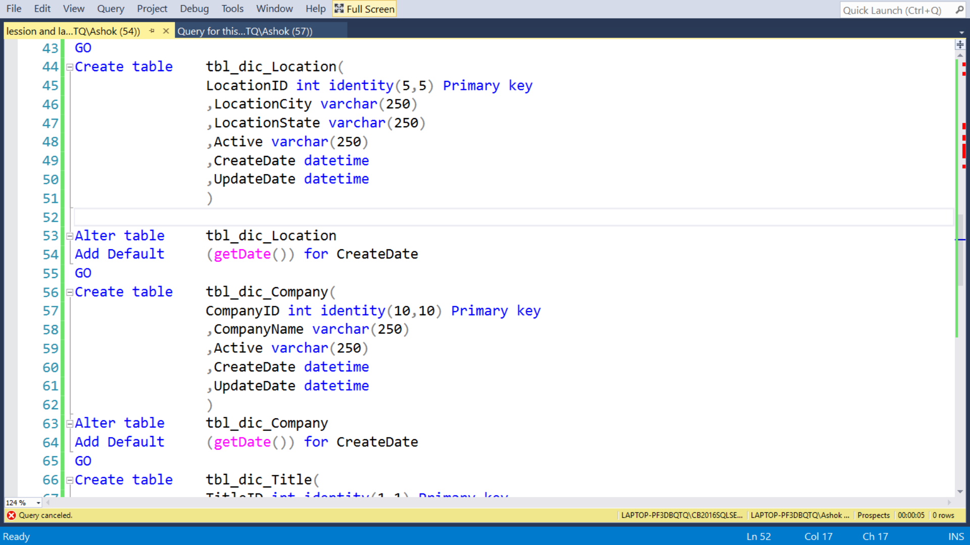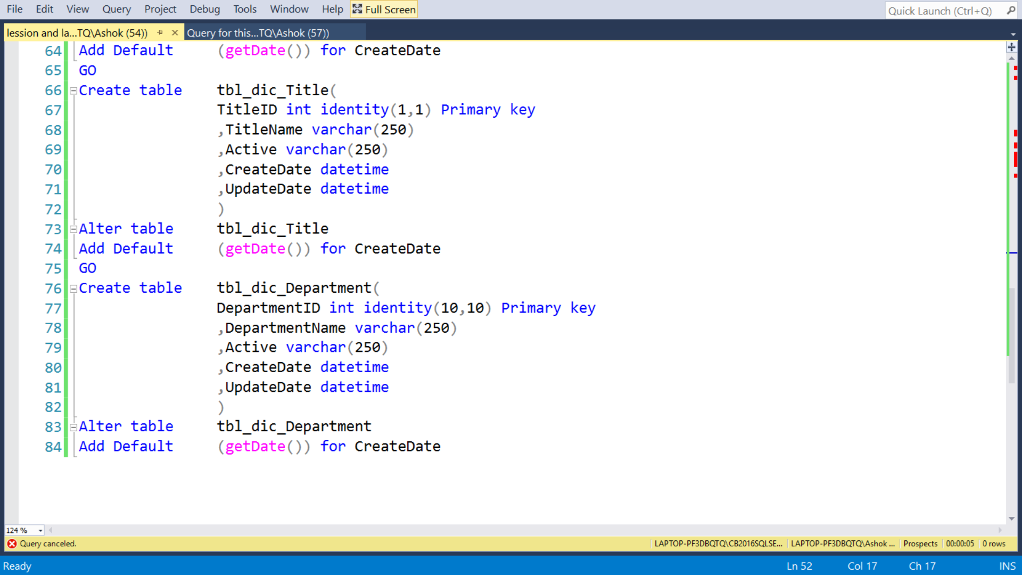

2... Create a SSIS package Load_Prospects_Dictionaries.dtsx to load the dictionary table (make

sure to lookup for records and insert/update accordingly the dictionary table)

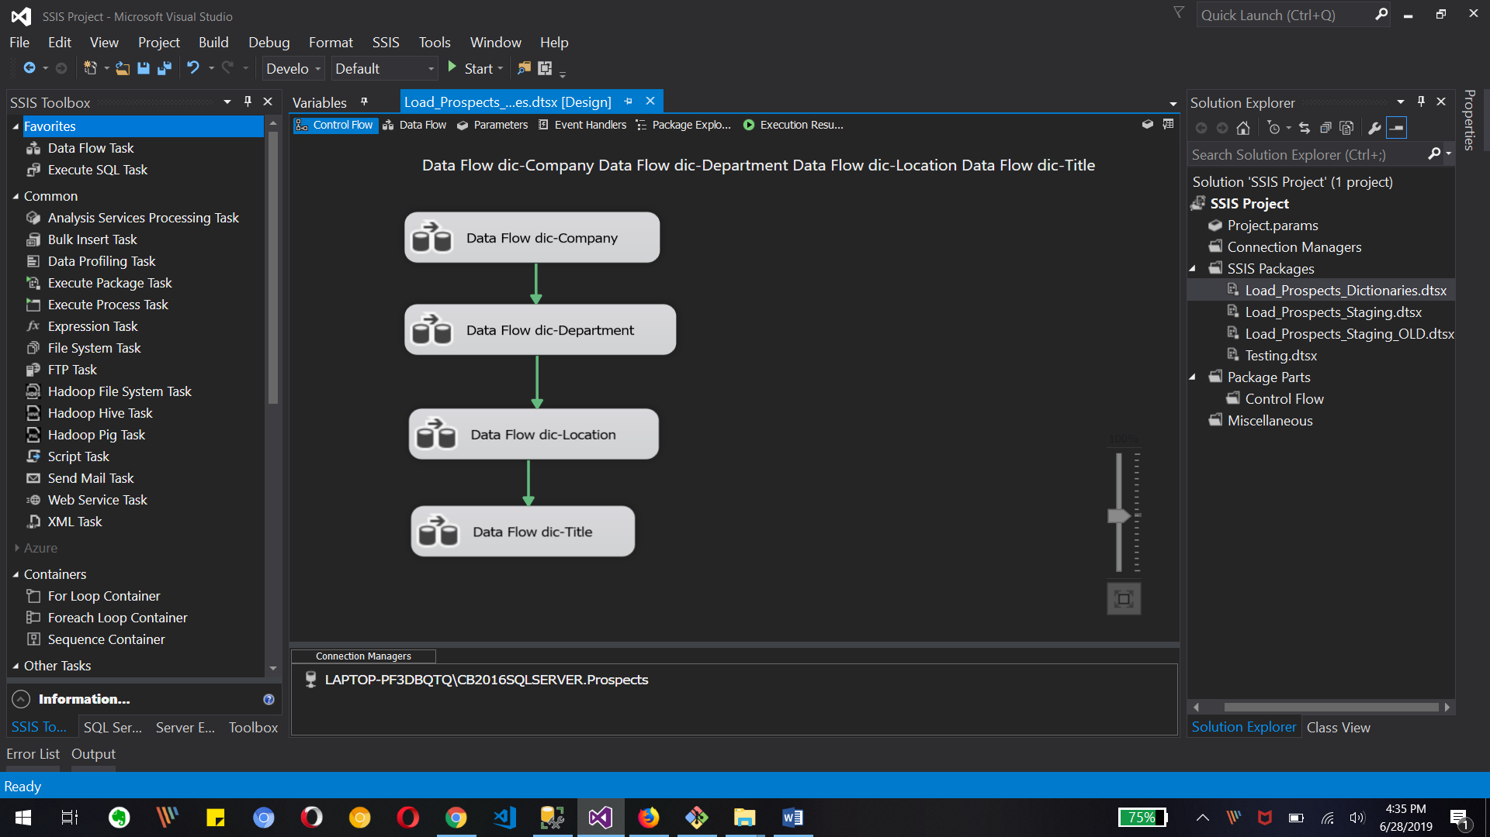

Data Flow dictionary-Company, dictionary -Department, dictionary -Location and dictionary-Title in Control flow tab

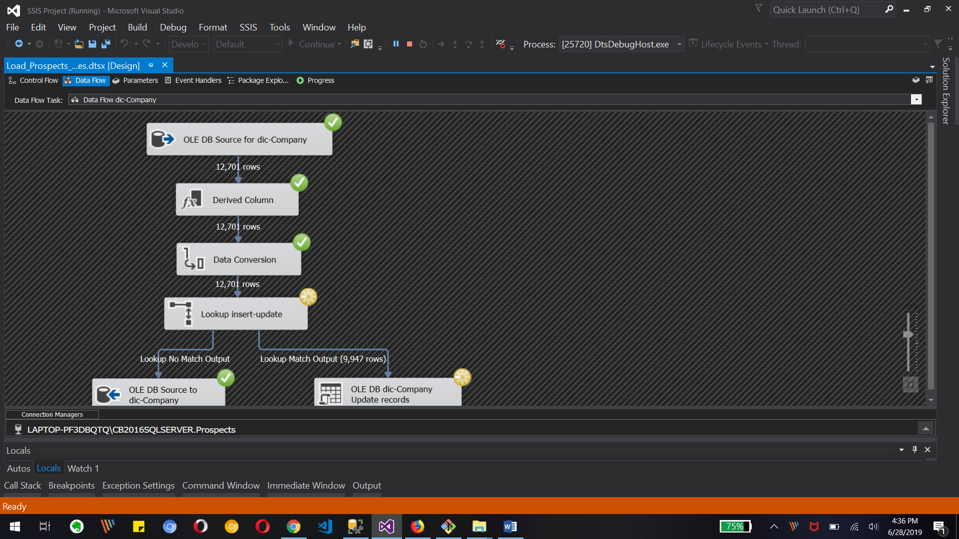

Debugging screen for dictionary-Company Data Flow

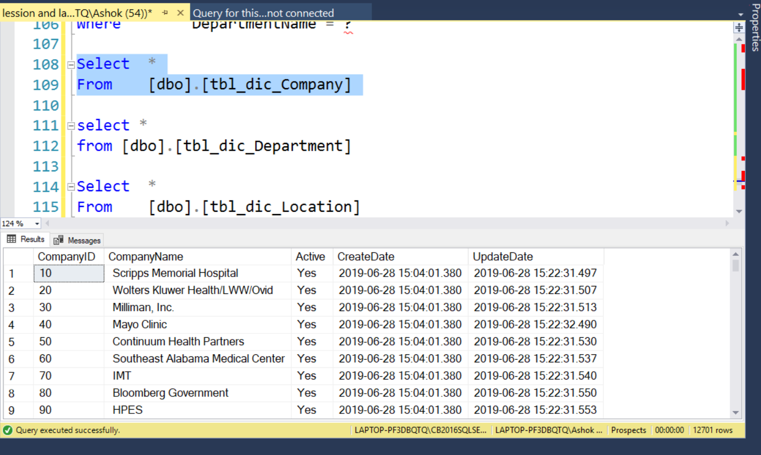

Updated records of Company table in SSMS

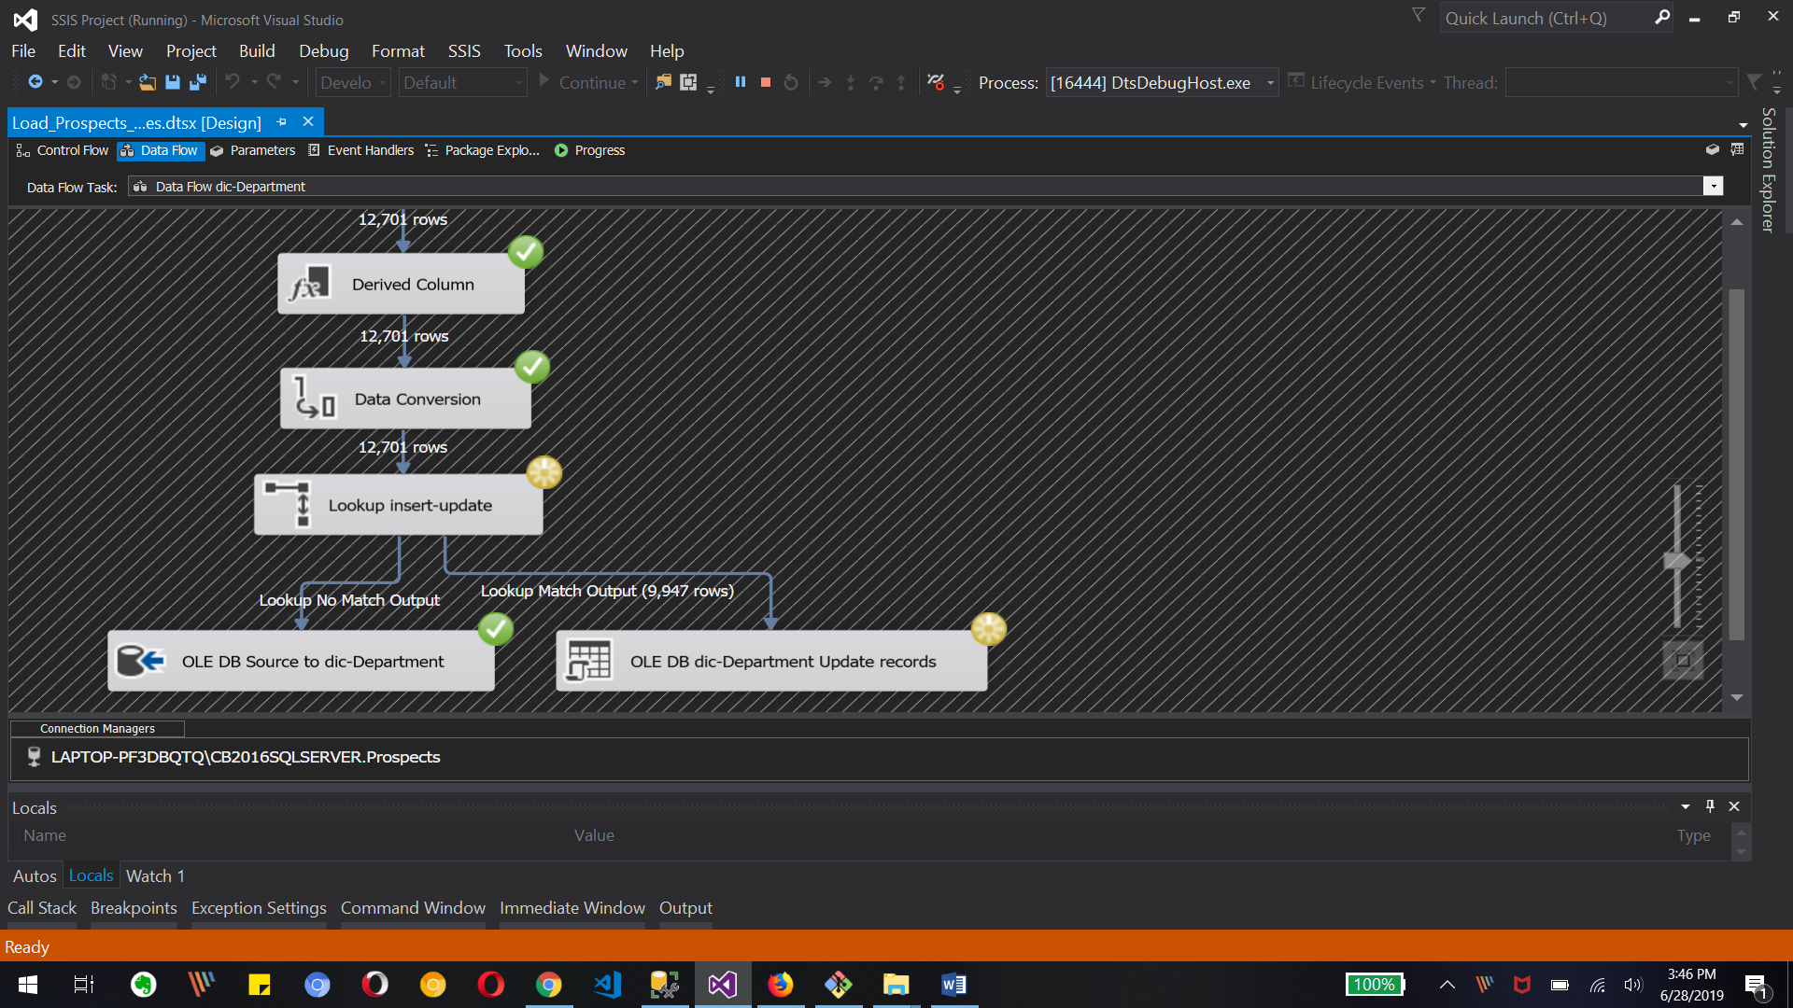

Debugging screen of dictionary-Deparment Data flow tasks

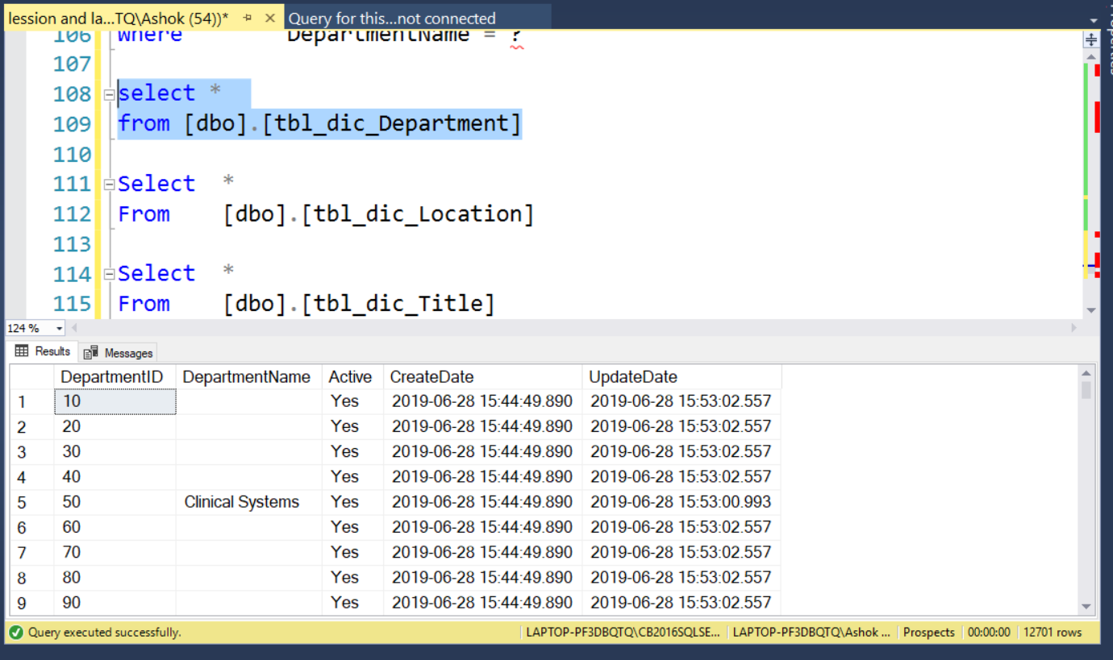

Updated records of Department table in SSMS

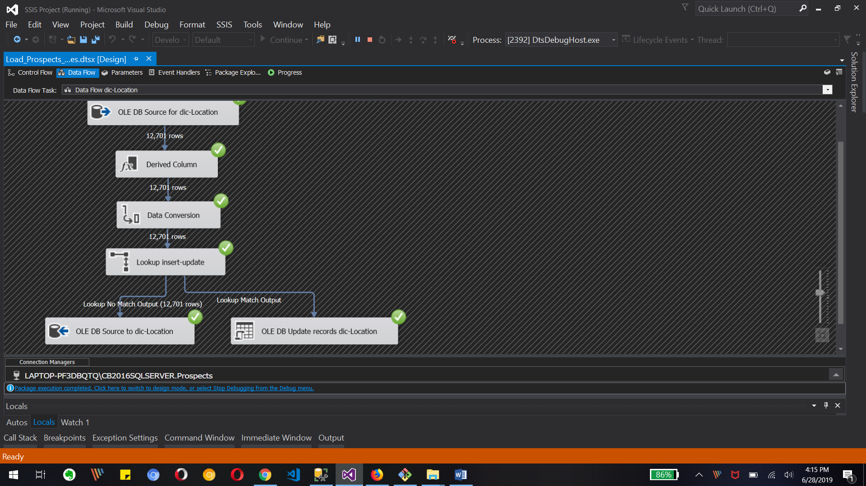

Debugging screen of dictionary-Location data flow tasks

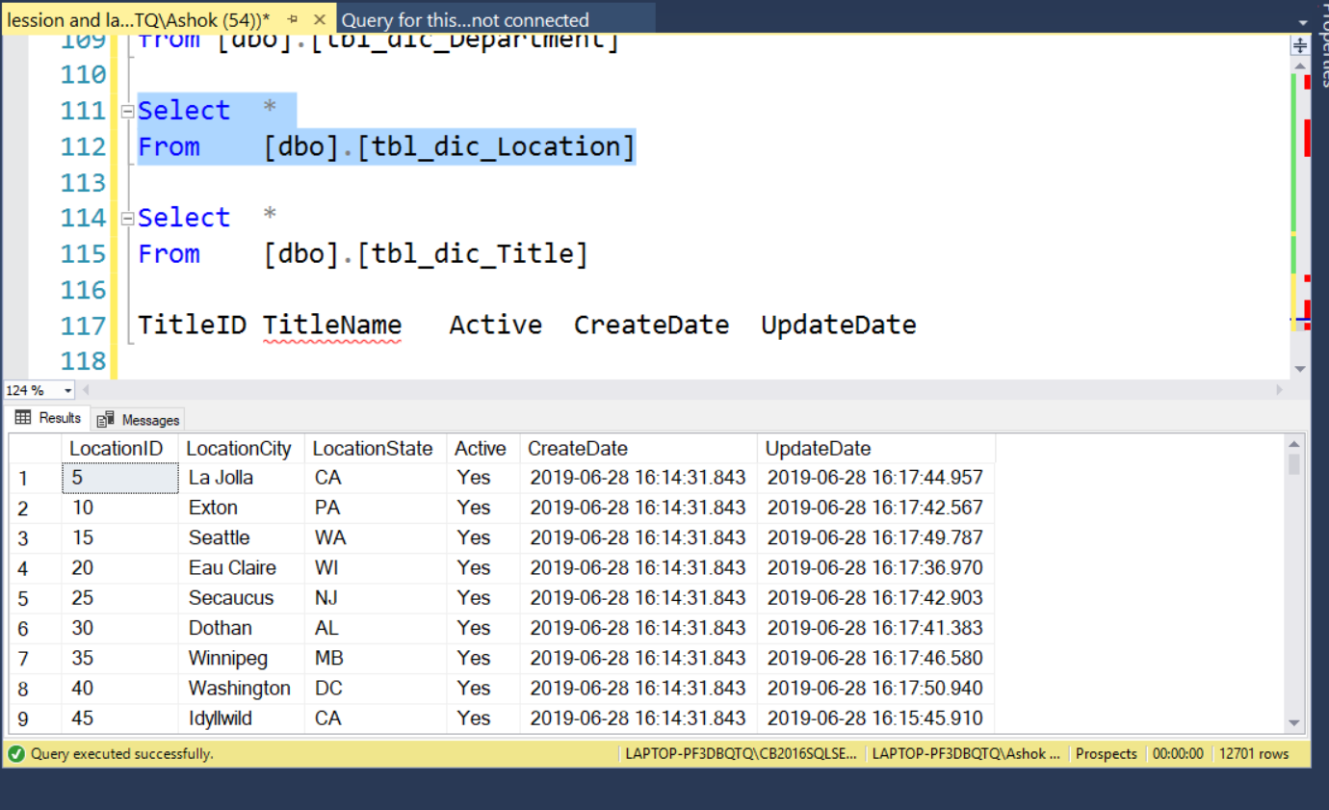

Updated records of Location table in SSMS

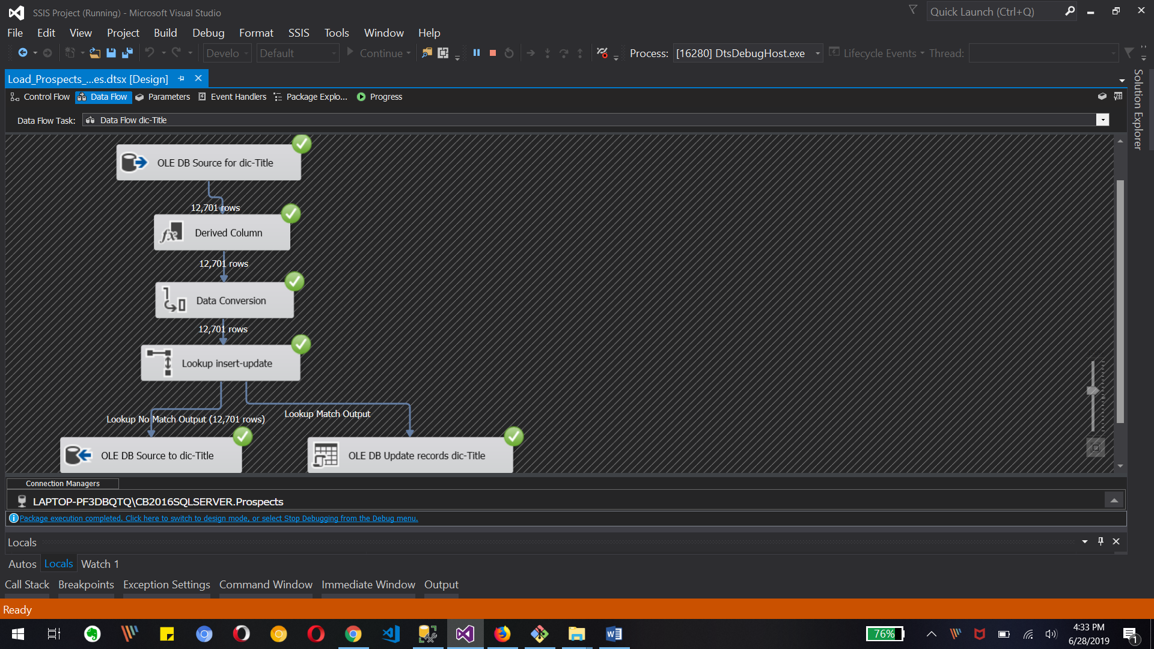

Debugging screen of dictionary-Title data flow tasks

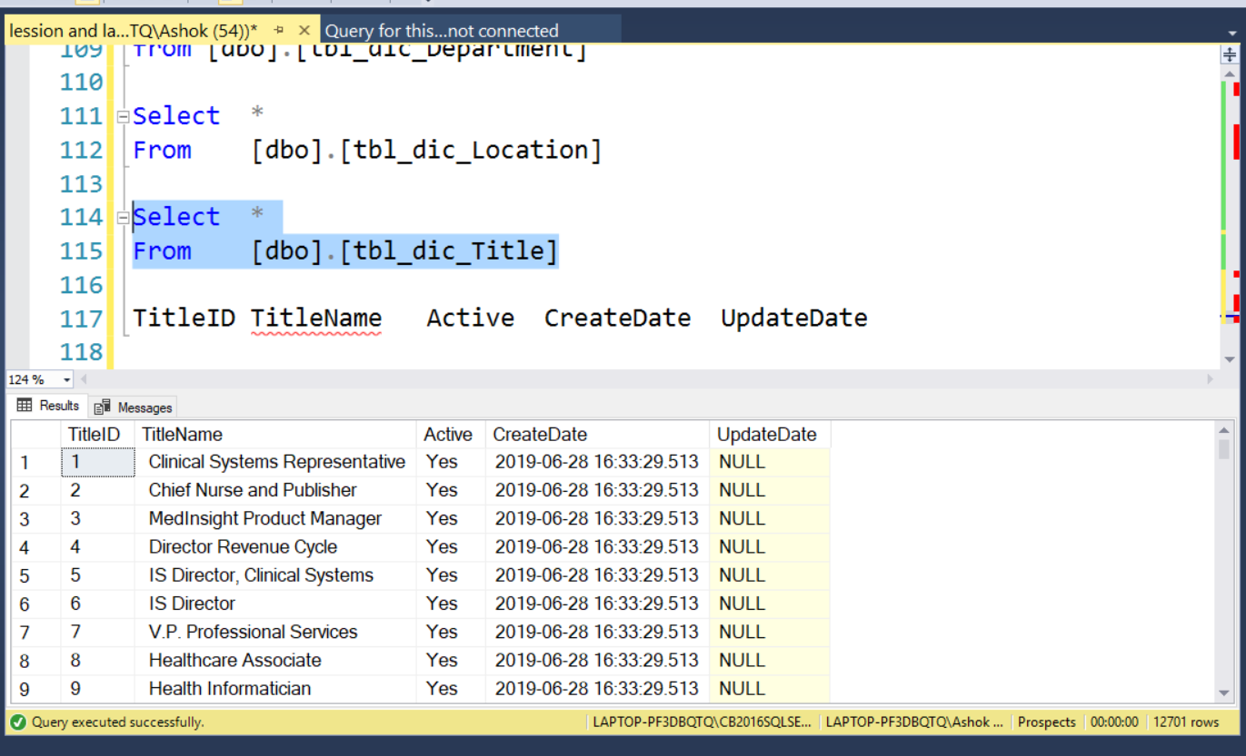

Updated records of Title table in SSMS

3. Create the audit table to log file load process – (Project document)

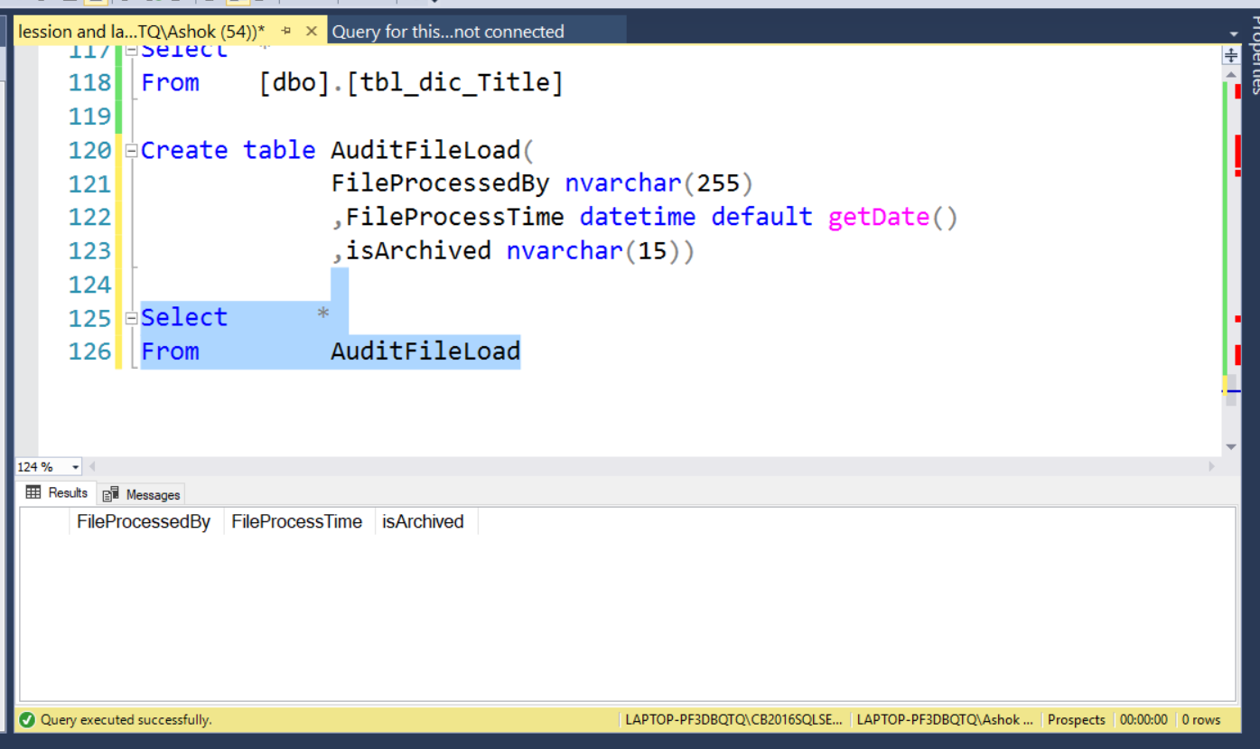

Creating AuditFileLoad table in Prospect database

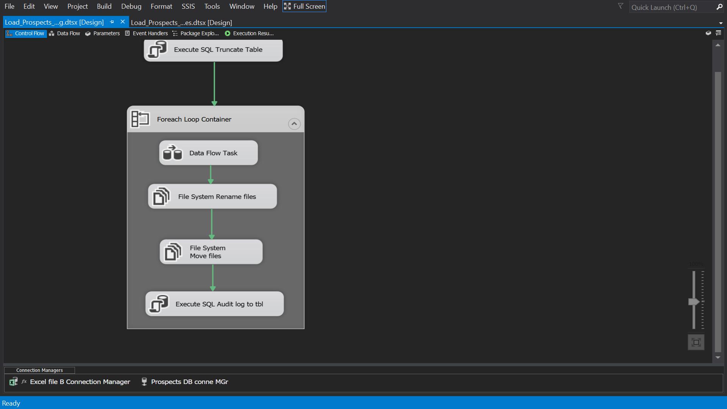

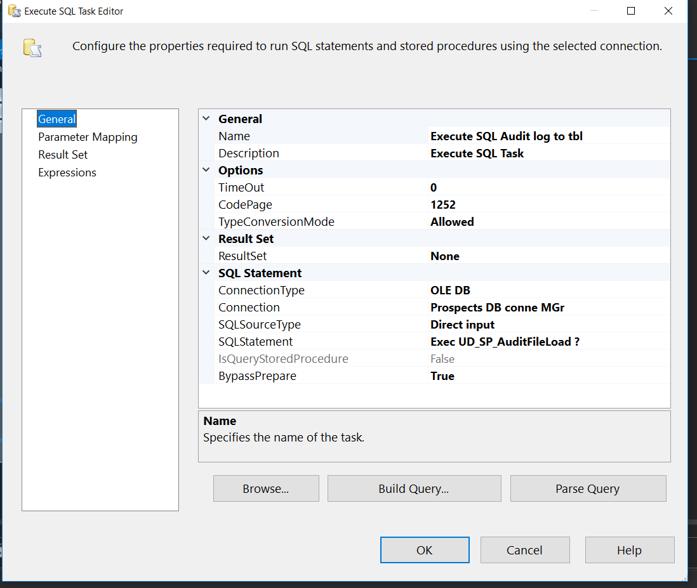

Creating Execute sql task for filling AudiFileLoad table

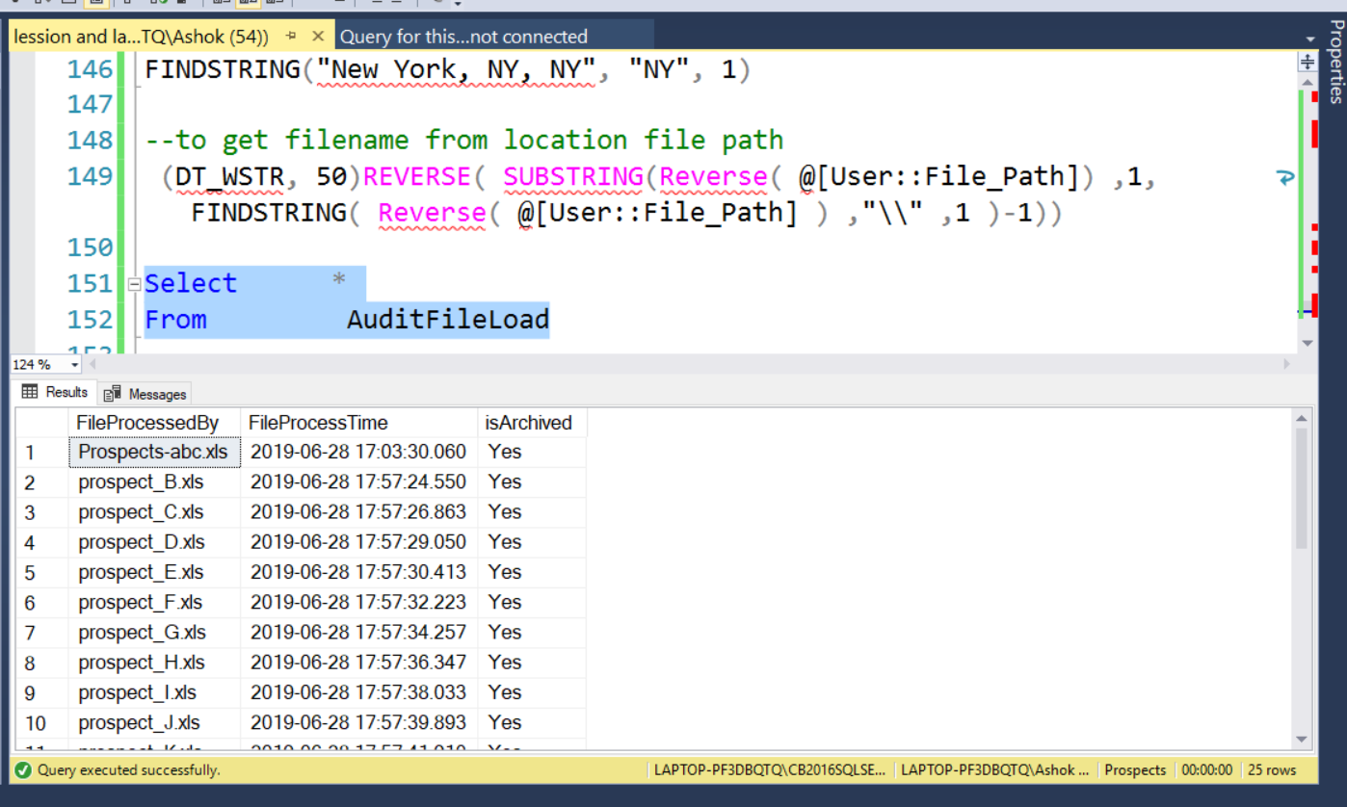

Final result of AudiFileLoad table after running SSIS package

4. Modify Load_Prospects_Staging.dtsx to include the following

a. Move the rejected files to the error folder

b. Get count of rows that were successfully inserted /updated and those that failed

validation.

c. Create separate error file for each file loaded containing the records that failed the NULL

validation that you implemented in Lab – 3.

d. Implement logging functionality in the package.

e. Implement error handling on the data flow task to avoid package failure in the event of

any unforeseen errors encountered.